|  |
| --- |
| Emergency Vehicle Indicator  By Manit Vig and Nishant Chandna |
| KIIT World School Zone – H4  Pitampura, Delhi -110034 |

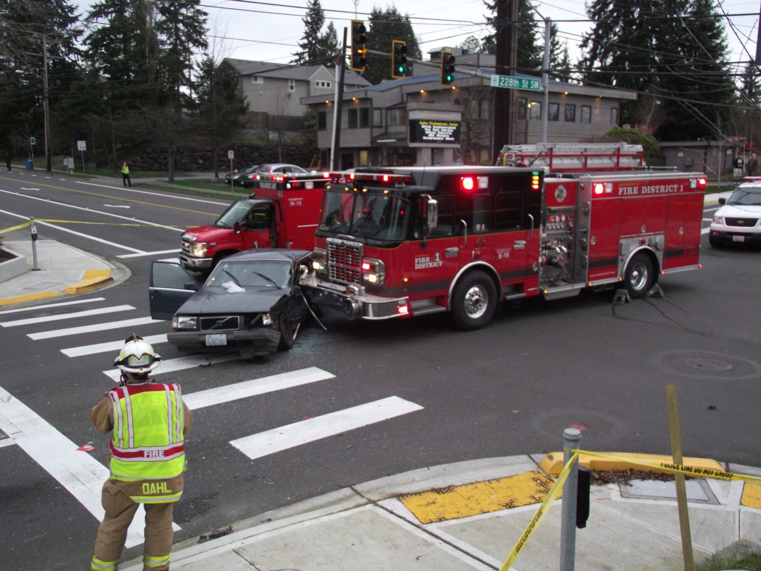



### **Introduction about the project**

### As per the latest stats there are almost 6500 accidents each year involving ambulances and in the past ten years there had been around 31,600 accidents involving firetrucks out of which almost 60% to 70% were at the time of emergency, more than 5000 people gets injured or die in accidents involving emergency vehicles.

### All these facts clearly state that emergency vehicles face a lot of problems while providing relief at times of an emergency making the emergency service system less efficient.

### As per analysis more than 20% of patient deaths are blamed on delay of emergency vehicles due to traffic jams and more than 50% of vehicles get late because they can’t get their way out of traffic.

### All this leading to major deaths and problems in country So, for this we have come up with a solution which we have named our **Emergency Vehicle Indicator.**

### Basically, it’s a tool which will indicate the traffic about an emergency vehicle approaching to them so that they can leave space for the ambulance or fire truck or police van to get their way out soon.

### **How is this done?**

### Our project first involves installation of a display board on all traffic signals of the region in which the system has to be set up. Then a device would be installed in all the emergency vehicles of the region. The device would be operated by the driver with a controller on the dash board of the vehicle.

### **Working of the indication system**

### As soon the emergency vehicle will get an emergency call the would turn on device with a button on the controller. The device which we are talking about is actually a radio transmitter which will transmit radio waves in a range of about 2 to 3 Km which would be carrying data of the longitude and latitude of the ambulance or fire truck which would be derived from a GPS module in the vehicle itself.

### When these waves would be received by the radio receiver on the nearby traffic signal it will calculate, with his direction-finding algorithm, the direction from which the emergency vehicle is approaching and will soon turn the traffic lights to one green and three red lights, thus letting the traffic in path of the emergency vehicle cleared out.

### 

### Also, it will turn on the display board which will indicate the drivers of other vehicles that an emergency vehicle is approaching and also its direction so that they drivers can let out way for the emergency vehicle.

### All this will make way clear for the emergency vehicles so that they can reach the victim’s place as fast and soon as possible and reducing the number of deaths caused by delay or accident of emergency vehicles

### **Management of multiple emergency vehicles**

### There could be a special case when multiple emergency vehicles have to use the same road, so for that scenario we need a management feature to prevent kayos and accidents and for the same our solution is:

### When the signal of an emergency vehicle would be received by the receiver on traffic signals the microcontroller would also set the priority of the vehicle so the signal to be received first will get the first priority and in the order of that generated priority, which would be displayed on the display board, the emergency vehicles will proceed to in their path. In short when multiple vehicles would need to use the same road there will be a proper plan for their dispersal and they will proceed turn by turn according to the priority set, this will ensure the smooth movement of traffic when there are multiple emergency vehicles on the same road.

### 

### **Components to be used**

### Arduino or any other microcontroller

### Arduino is an open-source microcontroller based on easy-to-use hardware and software.

### [microcontroller](https://www.arduino.cc/en/Main/Products) are able to read inputs - light on a sensor, a finger on a button, or a Twitter message - and turn it into an output - activating a motor, turning on an LED, publishing something online. We can tell our microcontroller what to do by sending a set of instructions to it

### **\*It would be more beneficial if we could use India’s own microprocessor Shakti in this project.**

### Image result for arduino

### RF (Radio Frequency) Transmitter and Receiver

One of the easiest and cheapest ways to implement wireless communication is using RF Module (Radio Frequency Module). By combining the two objects i.e. wireless communication with Arduino, we can create a wide range of applications like remote controlled cars, wirelessly operated robots, home automation, simple data transfer etc.In this project, we will use it to transfer the longitude and latitude of the emergency vehicle to signal board

### Image result for rf module arduino

### GPS Module

### Acronym to Global Positioning System, GPS is tool which can provide the location of any object on the planet globally. The data for the longitude and latitude of the emergency vehicle would be derived by this module.

### Image result for gps module arduino

### LED Dot Matrix Display Board

### A dot-matrix display is an electronic digital [display device](https://en.wikipedia.org/wiki/Display_device) that displays information on machines, clocks and watches, public transport departure indicators and many other devices requiring a simple display device of limited resolution. In this project it will display indication of a emergency vehicle on the traffic signals.

### Image result for led matrix display board

### **How will all this Technically Happen?**

### When emergency call would be received by the emergency vehicle the driver would turn on emergency button on the dash board then signal would be sent to the microcontroller stating that it is an emergency. Then the microcontroller will use GPS module to get the longitude and latitude of the vehicle. Then the co-ordinates would be transmitted through radio waves using the RF Transmitter on specific frequency.

### The receiver which would be installed on the traffic signals would be tuned to capture that specific frequency of radio waves. With this the receiver would get the data of the emergency vehicles and it will pass the data to the microcontroller/processor (if we used Shakti). The microcontroller will process the data with our direction determining algorithm which will tell the direction from which the emergency vehicle is approaching to the microcontroller and accordingly the microcontroller would turn on the emergency vehicle indication signal on the display board to indicate the other drivers about the emergency vehicle also it will turn the traffic signal to one green and other red letting traffic free for emergency vehicle.

### **Advantages**

### Will decrease the number of deaths in the country

### Will make the emergency relief system of the country more efficient and fast

### Its cost effective and has full price to performance ratio

### Provides new opportunities for employment

### It’s is totally Made In India

### It will increase the GDP of the Country

### **Cost Involved**

### With the calculation of total manufacturing costs and other investments this system would cost around ₹2000 to 3000 per traffic signal and ₹1000 to 2000 per emergency vehicle.

### **How will it provide employment opportunities?**

### This project can be used as a startup for a new company which can collaborate with the government to install this device all over the country also the company would require engineers, technicians, executives and other employees for various tasks and people could apply for jobs in those fields.

### Also, if this project is taken under by government it would still require technicians, engineers and human labour and this would also provide job opportunities.

### **Made In India**

### We want this system to be fully manufactured in India and also rather using components imported from foreign we want to use components made here itself in India like rather using Arduino which is a developed platform we would prefer using India’s own Shakti processor and other components also Made In India

### **Future Plans**

### **A special indication with google maps**

### Rather than only using a display board to indicate drivers of other vehicles for leaving space for emergency vehicle we also want another way in which indication could be more efficient and prior for which we plan to use Google’s API, **Google Maps** which is a navigation tool used by almost all of the population for day to day navigation.

### Our plan is to add a sort of notification in the app itself which would notify every driver using google maps about an emergency vehicle approaching toward himself in somewhat like this way:

### 

### This will make driver alert about an emergency vehicle a lot efficiently and prior but for this to happen we would have to collaborate with Google Inc. and request them to add this feature in their app.

### **Satellite determined path to make more efficient indication**

### We also want to indicate the other drivers not only about the approaching direction of the emergency vehicles but also about the direction in which the emergency vehicle would be going for we will try to use a satellite to determine the direction in which the emergency vehicle has to go by getting the current location of the emergency vehicle and location of its destination and then by generating the path in which the emergency vehicle should proceed with respect to live traffic and then it will inform the driver of the vehicle which path he should follow just like an navigation tool .

### Then the satellite will determine all the traffic lights in the path of the emergency vehicle and will send the data of the direction in which emergency vehicle would be going to all the traffic signals in the path.

### So, when the receivers will get signal of an emergency vehicle approaching to the traffic signal, they would also be knowing the direction in which it will go so it will indicate the other drivers about both the direction from which the emergency vehicle is coming and the direction in which it will be going, So, that they could leave space for the emergency vehicle more efficiently.

### **Complaint Hotline for those who use the lane left free for emergency vehicles**

### When people will using this system for leaving space for emergency vehicles they would probably leave a lane for the emergency vehicles but, there would be some people who would try use that lane which was to be used by the emergency vehicles to get away from traffic but won’t be justice to others who would get stuck in traffic just to let emergency vehicle its way out so for those people who misuse this system we want government to create a complaint hotline so that people could complaint regarding this misuse so that everybody gets justice and this would also provide a job opportunity.

### **Synopsis**

### Now to end this report we would again like to put stress on the fact that thousand of people lose their life just because emergency services can’t reach at time or they face an accident and all these facts state that our country is facing loss of many lives with just one problem and our project is the solution this problem. We want to equip are traffic lights with an additional display board to indicate people on road about an emergency vehicle approaching towards them. Our system first requires installation of a device on every emergency vehicle and installation of a display board on every traffic signal. When an emergency vehicle will get an emergency call the driver would have to turn on the device installed in their vehicle. This will start transmission of a radio signal from the emergency vehicle. When this signal would be received by the nearest traffic light in range of 2-3 Km it will determine the direction from which the emergency vehicle is approaching, then it would turn on indication on the display board which would tell other drivers the direction from which an emergency vehicle is approaching. With this information the drivers could leave space possibly a lane for the emergency vehicle to go, also along with this indication the receiver would also turn the traffic signal to one green and other red so that traffic in the path of emergency vehicle could be cleared. With implementation of this system we could save those thousand lives and make the emergency services in India more efficient.